An IoT based real time communication and location tracking system for vehicle emergency
ABSTRACT
Internet of Things is an emerging technology having the ability to change the way we live. In IoT vision, each and every ‘thing’ has the ability of talking to each other that brings the idea of Internet of Everything in reality. Numerous IoT services can make our daily life easier, smarter, and even safer. Using IoT in designing some special services can make a lifesaver system. In this paper, we have presented an IoT enabled approach that can provide emergency communication and location tracking services in a remote car that meets an unfortunate accident or any other emergency situation. Immediately after an accident or an emergency, the system either starts automatically or may be triggered manually. Depending upon type of emergency (police and security, fire and rescue, medical, or civil) it initiates communication and shares critical information e.g. location information, a set of relevant images taken from prefixed angles etc. with appropriate server / authority. Provision of interactive real-time multimedia communication, real-time location tracking etc. have also been integrated to the proposed system to monitor the exact condition in real-time basis.

CHAPTER-1
INTRODUCTION

Right now we are living in the era of Internet and rapidly moving towards a smart planet where every device will be connected to each other. Internet of Things (IoT) [1] is the technology helping us to achieve the goal of a smart world. IoT and Cyber Physical system [2] have the ability to change the vision of our way of living. All developing countries are aiming to transform their cities into Smart City [3] by taking several projects. For example, the government of India has taken an initiative called Digital India [4] to connect the nation to Internet. A. Necessity of Vehicular Emergency Communication System in Smart City Perspective In a smart city every device or better to say every ‘thing’ is connected 24 × 7 to the Ubiquitous network [5]. They can communicate to each other regardless of their communication protocols and hardware / software infrastructure. Machine to machine (M2M) communication [6] is rapidly growing to make the machines more intelligent and shared in nature. In this paper, we have used the concept of a smart city to provide a life savior system for a smart vehicle in any kind of emergency situation occurred on road. Most of the modern cars are well equipped with several sensors, mechanical devices, software, embedded hardware etc. to pre-detect collisions or crashes and avoid them. ‘Safety and security’ is one of the most important criteria of a vehicle. These kinds of modern safety systems are very much useful and reliable for car drivers as well as passengers on road. But those safety systems have one major limitation. These systems can only be used to avoid crashes. But unfortunately, if the system fails to avoid an accident or there is any other emergency situation other than accident, those systems have no provision to deal with them. If the driver gets sick while driving or some road blockage occurs or some mechanical problem occurs, those systems cant help. A study says that in India 141,526 people were killed on road in 2014 by different types of road accidents [7]. Most of them were killed due to late arrival of rescue teams to the accident location.

CHAPTER-2
EMBEDDED SYSTEMS
1.1 EMBEDDED SYSTEMS:
An embedded system is a computer system designed to perform one or a few dedicated functions often with real-time computing constraints. It is embedded as part of a complete device often including hardware and mechanical parts. By contrast, a general-purpose computer, such as a personal computer (PC), is designed to be flexible and to meet a wide range of end-user needs. Embedded systems control many devices in common use today.
Embedded systems are controlled by one or more main processing cores that are typically either microcontrollers or digital signal processors (DSP). The key characteristic, however, is being dedicated to handle a particular task, which may require very powerful processors. For example, air traffic control systems may usefully be viewed as embedded, even though they involve mainframe computers and dedicated regional and national networks between airports and radar sites. (Each radar probably includes one or more embedded systems of its own).
Since the embedded system is dedicated to specific tasks, design engineers can optimize it to reduce the size and cost of the product and increase the reliability and performance. Some embedded systems are mass-produced, benefiting from economies of scale.
Physically embedded systems range from portable devices such as digital watches and MP3 players, to large stationary installations like traffic lights, factory controllers, or the systems controlling nuclear power plants. Complexity varies from low, with a single microcontroller chip, to very high with multiple units, peripherals and networks mounted inside a large chassis or enclosure.
In general, "embedded system" is not a strictly definable term, as most systems have some element of extensibility or programmability. For example, handheld computers share some elements with embedded systems such as the operating systems and microprocessors which power them, but they allow different applications to be loaded and peripherals to be connected. Moreover, even systems which don't expose programmability as a primary feature generally need to support software updates. On a continuum from "general purpose" to "embedded", large application systems will have subcomponents at most points even if the system as a whole is "designed to perform one or a few dedicated functions", and is thus appropriate to call "embedded". A modern example of embedded system is shown in fig: 1.1.
Fig 1.1:A modern example of embedded system

Labeled parts include microprocessor (4), RAM (6), flash memory (7).Embedded systems programming is not like normal PC programming. In many ways, programming for an embedded system is like programming PC 15 years ago. The hardware for the system is usually chosen to make the device as cheap as possible. Spending an extra dollar a unit in order to make things easier to program can cost millions. Hiring a programmer for an extra month is cheap in comparison. This means the programmer must make do with slow processors and low memory, while at the same time battling a need for efficiency not seen in most PC applications. Below is a list of issues specific to the embedded field.
1.1.1 HISTORY:
In the earliest years of computers in the 1930–40s, computers were sometimes dedicated to a single task, but were far too large and expensive for most kinds of tasks performed by embedded computers of today. Over time however, the concept of programmable controllers evolved from traditional electromechanical sequencers, via solid state devices, to the use of computer technology.
One of the first recognizably modern embedded systems was the Apollo Guidance Computer, developed by Charles Stark Draper at the MIT Instrumentation Laboratory. At the project's inception, the Apollo guidance computer was considered the riskiest item in the Apollo project as it employed the then newly developed monolithic integrated circuits to reduce the size and weight. An early mass-produced embedded system was the Autonetics D-17 guidance computer for the Minuteman missile, released in 1961. It was built from transistor logic and had a hard disk for main memory. When the Minuteman II went into production in 1966, the D-17 was replaced with a new computer that was the first high-volume use of integrated circuits.
1.1.2 TOOLS:
Embedded development makes up a small fraction of total programming. There's also a large number of embedded architectures, unlike the PC world where 1 instruction set rules, and the Unix world where there's only 3 or 4 major ones. This means that the tools are more expensive. It also means that they're lower featured, and less developed. On a major embedded project, at some point you will almost always find a compiler bug of some sort.
Debugging tools are another issue. Since you can't always run general programs on your embedded processor, you can't always run a debugger on it. This makes fixing your program difficult. Special hardware such as JTAG ports can overcome this issue in part. However, if you stop on a breakpoint when your system is controlling real world hardware (such as a motor), permanent equipment damage can occur. As a result, people doing embedded programming quickly become masters at using serial IO channels and error message style debugging.
1.1.3 RESOURCES:
To save costs, embedded systems frequently have the cheapest processors that can do the job. This means your programs need to be written as efficiently as possible. When dealing with large data sets, issues like memory cache misses that never matter in PC programming can hurt you. Luckily, this won't happen too often- use reasonably efficient algorithms to start, and optimize only when necessary. Of course, normal profilers won't work well, due to the same reason debuggers don't work well.
Memory is also an issue. For the same cost savings reasons, embedded systems usually have the least memory they can get away with. That means their algorithms must be memory efficient (unlike in PC programs, you will frequently sacrifice processor time for memory, rather than the reverse). It also means you can't afford to leak memory. Embedded applications generally use deterministic memory techniques and avoid the default "new" and "malloc" functions, so that leaks can be found and eliminated more easily. Other resources programmers expect may not even exist. For example, most embedded processors do not have hardware FPUs (Floating-Point Processing Unit). These resources either need to be emulated in software, or avoided altogether.

1.1.4 REAL TIME ISSUES:
Embedded systems frequently control hardware, and must be able to respond to them in real time. Failure to do so could cause inaccuracy in measurements, or even damage hardware such as motors. This is made even more difficult by the lack of resources available. Almost all embedded systems need to be able to prioritize some tasks over others, and to be able to put off/skip low priority tasks such as UI in favor of high priority tasks like hardware control.
1.2 NEED FOR EMBEDDED SYSTEMS:
The uses of embedded systems are virtually limitless, because every day new products are introduced to the market that utilizes embedded computers in novel ways. In recent years, hardware such as microprocessors, microcontrollers, and FPGA chips have become much cheaper. So when implementing a new form of control, it's wiser to just buy the generic chip and write your own custom software for it. Producing a custom-made chip to handle a particular task or set of tasks costs far more time and money. Many embedded computers even come with extensive libraries, so that "writing your own software" becomes a very trivial task indeed. From an implementation viewpoint, there is a major difference between a computer and an embedded system. Embedded systems are often required to provide Real-Time response. The main elements that make embedded systems unique are its reliability and ease in debugging.

1.2.1 DEBUGGING:
Embedded debugging may be performed at different levels, depending on the facilities available. From simplest to most sophisticate they can be roughly grouped into the following areas:
- Interactive resident debugging, using the simple shell provided by the embedded operating system (e.g. Forth and Basic)
- External debugging using logging or serial port output to trace operation using either a monitor in flash or using a debug server like the Remedy Debugger which even works for heterogeneous multi core systems.
- An in-circuit debugger (ICD), a hardware device that connects to the microprocessor via a JTAG or Nexus interface. This allows the operation of the microprocessor to be controlled externally, but is typically restricted to specific debugging capabilities in the processor.
- An in-circuit emulator replaces the microprocessor with a simulated equivalent, providing full control over all aspects of the microprocessor.
- A complete emulator provides a simulation of all aspects of the hardware, allowing all of it to be controlled and modified and allowing debugging on a normal PC.
- Unless restricted to external debugging, the programmer can typically load and run software through the tools, view the code running in the processor, and start or stop its operation. The view of the code may be as assembly code or source-code.

Because an embedded system is often composed of a wide variety of elements, the debugging strategy may vary. For instance, debugging a software(and microprocessor) centric embedded system is different from debugging an embedded system where most of the processing is performed by peripherals (DSP, FPGA, co-processor). An increasing number of embedded systems today use more than one single processor core. A common problem with multi-core development is the proper synchronization of software execution. In such a case, the embedded system design may wish to check the data traffic on the busses between the processor cores, which requires very low-level debugging, at signal/bus level, with a logic analyzer, for instance.

1.2.2 RELIABILITY:
Embedded systems often reside in machines that are expected to run continuously for years without errors and in some cases recover by themselves if an error occurs. Therefore the software is usually developed and tested more carefully than that for personal computers, and unreliable mechanical moving parts such as disk drives, switches or buttons are avoided.
Specific reliability issues may include:
- The system cannot safely be shut down for repair, or it is too inaccessible to repair. Examples include space systems, undersea cables, navigational beacons, bore-hole systems, and automobiles.
- The system must be kept running for safety reasons. "Limp modes" are less tolerable. Often backups are selected by an operator. Examples include aircraft navigation, reactor control systems, safety-critical chemical factory controls, train signals, engines on single-engine aircraft.
- The system will lose large amounts of money when shut down: Telephone switches, factory controls, bridge and elevator controls, funds transfer and market making, automated sales and service.

A variety of techniques are used, sometimes in combination, to recover from errors—both software bugs such as memory leaks, and also soft errors in the hardware:
- Watchdog timer that resets the computer unless the software periodically notifies the watchdog
- Subsystems with redundant spares that can be switched over to
- software "limp modes" that provide partial function
- Designing with a Trusted Computing Base (TCB) architecture[6] ensures a highly secure & reliable system environment
- An Embedded Hypervisor is able to provide secure encapsulation for any subsystem component, so that a compromised software component cannot interfere with other subsystems, or privileged-level system software. This encapsulation keeps faults from propagating from one subsystem to another, improving reliability. This may also allow a subsystem to be automatically shut down and restarted on fault detection.
- Immunity Aware Programming

1.3 EXPLANATION OF EMBEDDED SYSTEMS
1.3.1 SOFTWARE ARCHITECTURE:
There are several different types of software architecture in common use.
- Simple Control Loop:
In this design, the software simply has a loop. The loop calls subroutines, each of which manages a part of the hardware or software.
- Interrupt Controlled System:
Some embedded systems are predominantly interrupt controlled. This means that tasks performed by the system are triggered by different kinds of events. An interrupt could be generated for example by a timer in a predefined frequency, or by a serial port controller receiving a byte. These kinds of systems are used if event handlers need low latency and the event handlers are short and simple.
Usually these kinds of systems run a simple task in a main loop also, but this task is not very sensitive to unexpected delays. Sometimes the interrupt handler will add longer tasks to a queue structure. Later, after the interrupt handler has finished, these tasks are executed by the main loop. This method brings the system close to a multitasking kernel with discrete processes.
- Cooperative Multitasking:
A non-preemptive multitasking system is very similar to the simple control loop scheme, except that the loop is hidden in an API. The programmer defines a series of tasks, and each task gets its own environment to “run” in. When a task is idle, it calls an idle routine, usually called “pause”, “wait”, “yield”, “nop” (stands for no operation), etc.The advantages and disadvantages are very similar to the control loop, except that adding new software is easier, by simply writing a new task, or adding to the queue-interpreter.
- Primitive Multitasking:
In this type of system, a low-level piece of code switches between tasks or threads based on a timer (connected to an interrupt). This is the level at which the system is generally considered to have an "operating system" kernel. Depending on how much functionality is required, it introduces more or less of the complexities of managing multiple tasks running conceptually in parallel.
As any code can potentially damage the data of another task (except in larger systems using an MMU) programs must be carefully designed and tested, and access to shared data must be controlled by some synchronization strategy, such as message queues, semaphores or a non-blocking synchronization scheme.
Because of these complexities, it is common for organizations to buy a real-time operating system, allowing the application programmers to concentrate on device functionality rather than operating system services, at least for large systems; smaller systems often cannot afford the overhead associated with a generic real time system, due to limitations regarding memory size, performance, and/or battery life.
- Microkernels And Exokernels:
A microkernel is a logical step up from a real-time OS. The usual arrangement is that the operating system kernel allocates memory and switches the CPU to different threads of execution. User mode processes implement major functions such as file systems, network interfaces, etc.
In general, microkernels succeed when the task switching and intertask communication is fast, and fail when they are slow. Exokernels communicate efficiently by normal subroutine calls. The hardware and all the software in the system are available to, and extensible by application programmers. Based on performance, functionality, requirement the embedded systems are divided into three categories:

1.3.2 STAND ALONE EMBEDDED SYSTEM:
These systems takes the input in the form of electrical signals from transducers or commands from human beings such as pressing of a button etc.., process them and produces desired output. This entire process of taking input, processing it and giving output is done in standalone mode. Such embedded systems comes under stand alone embedded systems
Eg: microwave oven, air conditioner etc..
1.3.3 REAL-TIME EMBEDDED SYSTEMS:
Embedded systems which are used to perform a specific task or operation in a specific time period those systems are called as real-time embedded systems. There are two types of real-time embedded systems.
- Hard Real-time embedded systems:
These embedded systems follow an absolute dead line time period i.e.., if the tasking is not done in a particular time period then there is a cause of damage to the entire equipment.
Eg: consider a system in which we have to open a valve within 30 milliseconds. If this valve is not opened in 30 ms this may cause damage to the entire equipment. So in such cases we use embedded systems for doing automatic operations.
- Soft Real Time embedded systems:
These embedded systems follow a relative dead line time period i.e.., if the task is not done in a particular time that will not cause damage to the equipment.
Eg: Consider a TV remote control system ,if the remote control takes a few milliseconds delay it will not cause damage either to the TV or to the remote control. These systems which will not cause damage when they are not operated at considerable time period those systems comes under soft real-time embedded systems.
1.3.4 NETWORK COMMUNICATION EMBEDDED SYSTEMS:
A wide range network interfacing communication is provided by using embedded systems.
Eg:
- Consider a web camera that is connected to the computer with internet can be used to spread communication like sending pictures, images, videos etc.., to another computer with internet connection throughout anywhere in the world.
- Consider a web camera that is connected at the door lock.
Whenever a person comes near the door, it captures the image of a person and sends to the desktop of your computer which is connected to internet. This gives an alerting message with image on to the desktop of your computer, and then you can open the door lock just by clicking the mouse.
Fig 1.2: Network communication embedded systems
1.3.5 DIFFERENT TYPES OF PROCESSING UNITS :
The central processing unit (c.p.u) can be any one of the following microprocessor, microcontroller, digital signal processing.
- Among these Microcontroller is of low cost processor and one of the main advantage of microcontrollers is, the components such as memory, serial communication interfaces, analog to digital converters etc.., all these are built on a single chip. The numbers of external components that are connected to it are very less according to the application.
- Microprocessors are more powerful than microcontrollers. They are used in major applications with a number of tasking requirements. But the microprocessor requires many external components like memory, serial communication, hard disk, input output ports etc.., so the power consumption is also very high when compared to microcontrollers.
- Digital signal processing is used mainly for the applications that particularly involved with processing of signals
1.4 APPLICATIONS F EMBEDDED SYSTEMS
1.4.1 CONSUMER APPLICATIONS:
At home we use a number of embedded systems which include microwave oven, remote control, vcd players, dvd players, camera etc….
Fig1.3: Automatic coffee makes equipment

1.4.2 OFFICE AUTOMATION:
We use systems like fax machine, modem, printer etc…
Fig1.4: Fax machine Fig1.5: Printing machine
1.4.3 INDUSTRIAL AUTOMATION:
Today a lot of industries are using embedded systems for process control. In industries we design the embedded systems to perform a specific operation like monitoring temperature, pressure, humidity ,voltage, current etc.., and basing on these monitored levels we do control other devices, we can send information to a centralized monitoring station.
Fig1.6: Robot
In critical industries where human presence is avoided there we can use robots which are programmed to do a specific operation.
1.4.4 COMPUTER NETWORKING:
Embedded systems are used as bridges routers etc..
Fig1.7: Computer networking
1.4.5 TELE COMMUNICATIONS:
Cell phones, web cameras etc.
Fig1.8: Cell Phone Fig1.9: Web camera

CHAPTER-2
BLOCK DIAGRAM
2.1 BLOCK DIAGRAM OVERVIEW:
Fig.2.1.block diagram.

- NODE MCU
- GPS MODULE
- L298N MOTOR DRIVER
- MOTORS
- BLYNK MOBILE APPLICATION

NODE MCU
NodeMCU is an open source firmware for which open source prototyping board designs are available. The name "NodeMCU" combines "node" and "MCU" (micro-controller unit). The term "NodeMCU" strictly speaking refers to the firmware rather than the associated development kits.
The NodeMCU (Node MicroController Unit) is an open source software and hardware development environment that is built around a very inexpensive System-on-a-Chip (SoC) called the ESP8266. ... However, as a chip, the ESP8266 is also hard to access and use.

GPS MODULE
GPS modules contain tiny processors and antennas that directly receive data sent by satellites through dedicated RF frequencies. From there, it'll receive timestamp from each visible satellites, along with other pieces of data.
GPS is a system of 30+ navigation satellites circling Earth. We know where they are because they constantly send out signals. A GPS receiver in your phone listens for these signals. Once the receiver calculates its distance from four or more GPS satellites, it can figure out where you are.
L298N MOTOR DRIVER
The L298N is a dual H-Bridge motor driver which allows speed and direction control of two DC motors at the same time. The module can drive DC motors that have voltages between 5 and 35V, with a peak current up to 2A.
L298n motor driver module uses the H-Bridge technique to control the direction of rotation of a DC motor. In this technique, H-Bridge controlled DC motor rotating direction by changing the polarity of its input voltage.
MOTOR
A dictionary describes, “a motor is a machine that converts electrical energy to mechanical energy.” In another words, the electrical energy is a “battery” and the mechanical energy is the “rotation.” To explain a motor physically, the well-known “Fleming's left hand rule” is a good approach.
The working principle of the electric motor mainly depends on the interaction of magnetic and electric field. The electric motor is mainly classified into two types. They are the AC motor and the DC motor. The AC motor takes alternating current as an input, whereas the DC motor takes direct current.
BLYNK MOBILE APPLICATION
Blynk is a Platform with IOS and Android apps to control Arduino, Raspberry Pi and the likes over the Internet. It's a digital dashboard where you can build a graphic interface for your project by simply dragging and dropping widgets.
It can control hardware remotely, it can display sensor data, it can store data, vizualize it and do many other cool things. There are three major components in the platform: Blynk App - allows to you create amazing interfaces for your projects using various widgets we provide.

PROPOSED SYSTEM
The proposed system is divided in three major parts, an onboard embedded device (situation node), emergency control terminal room and rescue center terminal. We have divided vehicular emergencies into five different types according to their characteristics. The details of each part is discussed in the following sections. + + + POLICE POLICE Hospital-1 Hospital-2 P Car Workshop-1 Car on Emergency-1 Local Control Room (Accidental Emergency) Car on Emergency-2 (Medical Emergency) Fig. 1: Architectural diagram of the proposed system for existing infrastructure A. Details of the System A vehicular emergency system is highly necessary and is an integral part of any smart city for proper safety, security, and reliability of smart living. Most important feature of this system is when a vehicle meets an accident the system starts automatically and track its location and takes some of its initial photos with the preinstalled cameras and send them immediately to the emergency control room. The control room system automatically finds the nearest hospital and police station and forwards the message to them. Now the hospital and police station authority analyze the situation with the help of initial photos and send rescue teams to the accident location. We have divided emergency situations in five different categories as follows.
• Type-1(Accident): This is the most important emergency type for a vehicle on road. When a vehicle crashes or meets any accident the system sends the emergency message to the nearest hospital and police station. Also, the preinstalled cameras activate only for this type of emergency to help the rescue teams to understand the real scenario of the situation from the base station and act accordingly.
• Type-2 (Medical): Sometime it happens that a passenger or the driver of a car suddenly becomes sick and is unable to go to the hospital or find any hospital nearby. In that case, they can start the system manually and define the emergency type to medical issue. For this type of emergency the control room sends the message to the 672 nearest hospital as emergency medical situation and the hospital acts accordingly.
• Type-3 (Criminal): If a car meets some criminal issue, they can also contact the control room for help. For this case the nearest police station is informed.
• Type-4 (Civil): If there is any natural calamity, and the road is blocked by some barrier, the nearest government civil service office and police station are informed.
• Type-5 (Mechanical): If a vehicle meets some mechanical problems, nearest car workshop is informed. Table I summarizes different types of emergencies, resp

SOFTWER DISCRIPTION

Pin Description
Pin Number | Pin Name | Description
1 | Ground | System Ground
2,3 | CAM1_DN0, CAM1_DP0 | MIPI Data Positive and MIPI Data Negative for data lane 0
4 | Ground | System Ground
5,6 | CAM1_DN1, CAM1_DP1 | MIPI Data Positive and MIPI Data Negative for data lane 1
7 | Ground | System Ground
8,9 | CAM1_CN, CAM1_CP | These pins provide the clock pulses for MIPI data lanes
10 | Ground | System Ground
11 | CAM_GPIO | GPIO pin used optionally
12 | CAM_CLK | Optional clock pin
13,14 | SCL0, SDA0 | Used for I2C communication
15 | +3.3V | Power pin

PiCam Features
- 5MP colour camera module without microphone for Raspberry Pi
- Supports both Raspberry Pi Model A and Model B
- MIPI Camera serial interface
- Omnivision 5647 Camera Module
- Resolution: 2592 * 1944
- Supports: 1080p, 720p and 480p
- Light weight and portable (3g only)
Note: Complete Technical Details can be found at the PiCam datasheet given at the end of this page.

Alternatives Camera module for Raspberry Pi
IR Night Vision camera, USB Camera, 8MP MIPI Camera, 5MP Wide angle camera with IR.

How to use Camera module with Pi
The Pi camera module when purchased comes along with a ribbon cable, this cable has to be connected to the CSI (Camera Serial Interface) port of the Pi. This port can be found near the HDMI port just connect the cable to it as shown below.

Applications
- Surveillance projects
- Time-lapse video recording
- Image processing
- Machine learning
- Robotics

2D-Model (Dimensions)
If you are making a casing for the Pi module these dimensions should help you.

ARDUINO :
Arduino is an open-source platform used for building electronics projects. Arduino consists of both a physical programmable circuit board (often referred to as a microcontroller) and a piece of software, or IDE (Integrated Development Environment) that runs on your computer, used to write and upload computer code to the physical board. The Arduino platform has become quite popular with people just starting out with electronics, and for good reason. Unlike most previous programmable circuit boards, the Arduino does not need a separate piece of hardware (called a programmer) in order to load new code onto the board – you can simply use a USB cable. Additionally, the Arduino IDE uses a simplified version of C++, making it easier to learn to program. Finally, Arduino provides a standard form factor that breaks out the functions of the micro-controller into a more accessible package.

Fig5.1: Arduino Uno Fig 5.2:This is a screenshot of the Arduino IDE The Uno is one of the more popular boards in the Arduino family and a great choice for beginners. We’ll talk about what’s on it and what it can do later in the tutorial. What Does it Do? The Arduino hardware and software was designed for artists, designers, hobbyists, hackers, newbies, and anyone interested in creating interactive objects or environments. Arduino can interact with buttons, LEDs, motors, speakers, GPS units, cameras, the internet, and even your smart-phone or your TV! This flexibility combined with the fact that the Arduino software is free, the hardware boards are pretty cheap, and both the software and hardware are easy to learnhas led to a large community of users who have contributed code and released instructions for a huge variety of Arduino-based projects

Pin Description
Pin Category | Pin Name | Details
Power | Vin, 3.3V, 5V, GND | Vin: Input voltage to Arduino when using an external power source.  5V: Regulated power supply used to power microcontroller and other components on the board.  3.3V: 3.3V supply generated by on-board voltage regulator. Maximum current draw is 50mA.  GND: ground pins.
Reset | Reset | Resets the microcontroller.
Analog Pins | A0 – A5 | Used to provide analog input in the range of 0-5V
Input/Output Pins | Digital Pins 0 - 13 | Can be used as input or output pins.
Serial | 0(Rx), 1(Tx) | Used to receive and transmit TTL serial data.
External Interrupts | 2, 3 | To trigger an interrupt.
PWM | 3, 5, 6, 9, 11 | Provides 8-bit PWM output.
SPI | 10 (SS), 11 (MOSI), 12 (MISO) and 13 (SCK) | Used for SPI communication.
Inbuilt LED | 13 | To turn on the inbuilt LED.
TWI | A4 (SDA), A5 (SCA) | Used for TWI communication.
AREF | AREF | To provide reference voltage for input voltage.

Arduino Uno Technical Specifications
Microcontroller | ATmega328P – 8 bit AVR family microcontroller
Operating Voltage | 5V
Recommended Input Voltage | 7-12V
Input Voltage Limits | 6-20V
Analog Input Pins | 6 (A0 – A5)
Digital I/O Pins | 14 (Out of which 6 provide PWM output)
DC Current on I/O Pins | 40 mA
DC Current on 3.3V Pin | 50 mA
Flash Memory | 32 KB (0.5 KB is used for Bootloader)
SRAM | 2 KB
EEPROM | 1 KB
Frequency (Clock Speed) | 16 MHz

Other Arduino Boards
Arduino Nano, Arduino Pro Mini, Arduino Mega, Arduino Due, Arduino Leonardo

Overview
Arduino Uno is a microcontroller board based on 8-bit ATmega328P microcontroller. Along with ATmega328P, it consists other components such as crystal oscillator, serial communication, voltage regulator, etc. to support the microcontroller. Arduino Uno has 14 digital input/output pins (out of which 6 can be used as PWM outputs), 6 analog input pins, a USB connection, A Power barrel jack, an ICSP header and a reset button.

How to use Arduino Board
The 14 digital input/output pins can be used as input or output pins by using pinMode(), digitalRead() and digitalWrite() functions in arduino programming. Each pin operate at 5V and can provide or receive a maximum of 40mA current, and has an internal pull-up resistor of 20-50 KOhms which are disconnected by default. Out of these 14 pins, some pins have specific functions as listed below:
- Serial Pins 0 (Rx) and 1 (Tx): Rx and Tx pins are used to receive and transmit TTL serial data. They are connected with the corresponding ATmega328P USB to TTL serial chip.
- External Interrupt Pins 2 and 3: These pins can be configured to trigger an interrupt on a low value, a rising or falling edge, or a change in value.
- PWM Pins 3, 5, 6, 9 and 11: These pins provide an 8-bit PWM output by using analogWrite() function.
- SPI Pins 10 (SS), 11 (MOSI), 12 (MISO) and 13 (SCK): These pins are used for SPI communication.
- In-built LED Pin 13: This pin is connected with an built-in LED, when pin 13 is HIGH – LED is on and when pin 13 is LOW, its off.
Along with 14 Digital pins, there are 6 analog input pins, each of which provide 10 bits of resolution, i.e. 1024 different values. They measure from 0 to 5 volts but this limit can be increased by using AREF pin with analog Reference() function.
- Analog pin 4 (SDA) and pin 5 (SCA) also used for TWI communication using Wire library.
Arduino Uno has a couple of other pins as explained below:
- AREF: Used to provide reference voltage for analog inputs with analogReference() function.
- Reset Pin: Making this pin LOW, resets the microcontroller.

Communication
Arduino can be used to communicate with a computer, another Arduino board or other microcontrollers. The ATmega328P microcontroller provides UART TTL (5V) serial communication which can be done using digital pin 0 (Rx) and digital pin 1 (Tx). An ATmega16U2 on the board channels this serial communication over USB and appears as a virtual com port to software on the computer. The ATmega16U2 firmware uses the standard USB COM drivers, and no external driver is needed. However, on Windows, a .inf file is required. The Arduino software includes a serial monitor which allows simple textual data to be sent to and from the Arduino board. There are two RX and TX LEDs on the arduino board which will flash when data is being transmitted via the USB-to-serial chip and USB connection to the computer (not for serial communication on pins 0 and 1). A SoftwareSerial library allows for serial communication on any of the Uno's digital pins. The ATmega328P also supports I2C (TWI) and SPI communication. The Arduino software includes a Wire library to simplify use of the I2C bus.

Arduino Uno to ATmega328 Pin Mapping
When ATmega328 chip is used in place of Arduino Uno, or vice versa, the image below shows the pin mapping between the two.
Perhaps the most popular board in the Arduino line-up is the Arduino UNO. There are other boards like the Arduino Nano and the Arduino Mega, but UNO has been the go-to board for quick prototyping, Arduino Projects and DIY Projects.
Arduino UNO in DIP and SMD Packages
Arduino UNO is based on ATmega328P Microcontroller, an 8-bit AVR Architecture based MCU from ATMEL. Arduino UNO comes in two variants: one consists of a 28-pin DIP Microcontroller while the other consists of 32 lead Quad Flat Package Microcontroller.
Other than that, rest is identical in both the boards.

Arduino UNO Board Layout
The following image shows the layout of a typical Arduino UNO board. All the components are placed on the top side of the PCB.
Layout of Arduino UNO Board
As you can notice, there is a Type-B USB connector on the left short edge of the board, which is used for powering on the board as well as programming the Microcontroller. There is also a 2.1 mm DC jack to provide external power supply.
Apart from that, the layout of Arduino UNO is very much self-explanatory.
I will discuss about the pins of Arduino UNO in the Arduino UNO Pinout Section.

Technical Specifications of Arduino UNO
As Arduino UNO is based on ATmega328P Microcontroller, the technical specifications of Arduino UNO are mostly related to the ATmega328P MCU. But none the less, let me give you a brief overview about some important specifications of Arduino UNO.
MCU | ATmega328P
Architecture | AVR
Operating Voltage | 5V
Input Voltage | 6V – 20V (limit)  7V – 12V (recommended)
Clock Speed | 16 MHz
Flash Memory | 32 KB (2 KB of this used by bootloader)
SRAM | 2 KB
EEPROM | 1 KB
Digital IO Pins | 24 (of which 6 can produce PWM)
Analog Input Pins | 6

How to power up the Arduino UNO?
There are a couple of ways in which you can power the UNO board. The first and easy way is using the Type-B USB Connector. The next way is to provide an unregulated supply in the range of 6V to 20V to VIN pin of the UNO (Pin number 26).
You can also supply the unregulated supply through the 2.1mm DC Jack, in which case, you can access the supplied voltage through the VIN Pin.

What are Different Memories of Arduino UNO?
Strictly speaking, this is specific to the MCU i.e., ATmega328P, used on the Arduino UNO Board. There are three different memories available in ATmega328P. They are:
- 32 KB of Flash Memory
- 2 KB of SRAM
- 1 KB of EEPROM
- 0.5 KB of the Flash Memory is used by the bootloader code.

What are the Input and Output Pins of Arduino UNO?
Of the 32 pins available on the UNO board, 22 pins are associated with input and output. In that 14 pins (D0 to D13) are true digital IO pins, which can be configured as per you application using pinMode(), digitalWrite() and digitalRead() functions.
All these Digital IO pins are capable of sourcing or sinking 20mA of current (maximum 40mA is allowed). An additional feature of the Digital IO pins is the availability of internal pull-up resistor (which is not connected by default).
The value of the internal pull-up resistor will be in the range of 20KΩ to 50KΩ.
There are also 6 Analog Input Pins (A0 to A5). All the analog input pins provide a 10-bit resolution ADC feature, which can be read using analogRead() function.
An important point about Analog Input pins is that they can be configured as Digital IO pins, if required.
Digital IO pins 3, 5, 6, 9, 10 and 11 are capable of producing 8-bit PWM Signals. You can use analogWrite() function for this.

What Communication Interfaces are available on Arduino UNO?
Arduino UNO supports three different types of communication interfaces. They are:
- Serial
- I2C or I²C
- SPI
Perhaps the most common communication interface in the Arduino universe is the Serial Communication. In fact, the Arduino boards (UNO or Nano or Mega) are programmed using the serial communication.
Digital IO pins 0 and 1 are used as Serial RX and TX pins to receive and transmit serial data. These pins are connected to the serial pins of the on-board USB to Serial Converter IC.
Analog Input Pins A4 and A5 have alternative functions. They can be configured as SDA (A4) and SCL (A5) to support I2C or I²C or Two Wire Interface (TWI) communication.
The final communication interface is the SPI. Digital IO Pins 10, 11 12 and 13 can be configured as SPI pins SS, MOSI, MISO and SCK respectively.

Any additional features?
There is an on-board LED connected to digital IO pin 13. Use this LED to perform Blinky operations. The reference voltage for the internal ADC is by default set to 5V. But using the AREF pin, you can manually set the upper limit of the ADC.
Using the IOREF pin, you can set the reference voltage for Microcontroller operations.
To reset the microcontroller, you can use the on-board RESET button.
Although you can program the Arduino UNO using the USB cable, there is a provision to program the MCU using the In-Circuit Serial Programming (ICSP) interface.
The UART bootloader, which is preloaded in to the ATmega328P microcontroller, enables programming through serial interface. But ICSP doesn’t need any bootloader.
You can program Arduino UNO using ISCP or use the ISCP of Arduino UNO to program other Arduino Boards.
Digital IO Pins 2 and 3 can be configured as External Interrupts Pins INT0 and INT1 respectively. Use attachInterrupt() function to configure the Interrupt for rising edge, falling edge or level change on the pin.

Arduino UNO Pinout
Now that we have seen a little bit about Arduino UNO and its important features and specifications, let us dive into the Arduino UNO Pinout. The following image shows the complete pinout of Arduino UNO Board.
As you can see from the image, I described each pin of the Arduino UNO with its microcontroller equivalent pin, alternative functions, default functionality and other additional features.
For higher resolution image, click here.

Pin Description
For pin description of Arduino UNO, let us assume some basic numbering. Let the numbering begin with the RX Pin (D0). So, RX is Pin 1, TX is Pin 2, D2 is Pin 3 and so on.
On the other side, NC is Pin 19, IOREF is Pin 20 etc. Overall, there are 32 pins on the Arduino UNO Board.
With this information, let us now see the pin description of Arduino UNO.
Pin Number | Pin Name | Description | Alternative Functions
1 | RX / D0 | Digital IO Pin 0  Serial RX Pin | Generally used as RX
2 | TX / D1 | Digital IO Pin 1  Serial TX Pin | Generally used as TX
3 | D2 | Digital IO Pin 2
4 | D3 | Digital IO Pin 3 | Timer (OC2B)
5 | D4 | Digital IO Pin 4 | Timer (T0/XCK)
6 | D5 | Digital IO Pin 5 | Timer (OC0B/T1)
7 | D6 | Digital IO Pin 6
8 | D7 | Digital IO Pin 7
9 | D8 | Digital IO Pin 8 | Timer (CLK0/ICP1)
10 | D9 | Digital IO Pin 9 | Timer (OC1A)
11 | D10 | Digital IO Pin 10 | Timer (OC1B)
12 | D11 | Digital IO Pin 11 | SPI (MOSI) Timer (OC2A)
13 | D12 | Digital IO Pin 12 | SPI (MISO)
14 | D13 | Digital IO Pin 13 | SPI (SCK)
15 | GND | Ground
16 | AREF | Analog Reference
17 | SDA / D18 | Digital IO Pin 18 | I2C Data Pin
18 | SCL / D19 | Digital IO Pin 19 | I2C Clock Pin
19 | NC | Not Connected
20 | IOREF | Voltage Reference
21 | RESET | Reset (Active LOW)
22 | 3V3 | Power
23 | 5V | +5V Output from regulator or +5V regulated Input
24 | GND | Ground
25 | GND | Ground
26 | VIN | Unregulated Supply
27 | A0 | Analog Input 0 | Digital IO Pin 14
28 | A1 | Analog Input 1 | Digital IO Pin 15
29 | A2 | Analog Input 2 | Digital IO Pin 16
30 | A3 | Analog Input 3 | Digital IO Pin 17
31 | A4 | Analog Input 4 | Digital IO Pin 18 I2C (SDA)
32 | A5 | Analog Input 5 | Digital IO Pin 19 I2C (SCL)
The following table describes the pins of the ICSP Connector.
MISO | Master In Slave Out (Input or Output)
5V | Supply
SCK | Clock (from Master to Slave)
MOSI | Master Out Slave In (Input or Output)
RESET | Reset (Active LOW)
GND | Ground
There is also a similar ICSP connector known as ICSP1 associated with the ATmega16U Microcontroller. For more information on this connector, take a look at the Arduino UNO Pinout image.

Software
Arduino IDE (Integrated Development Environment) is required to program the Arduino Uno board. Download it here.

Programming Arduino
Once arduino IDE is installed on the computer, connect the board with computer using USB cable. Now open the arduino IDE and choose the correct board by selecting Tools>Boards>Arduino/Genuino Uno, and choose the correct Port by selecting Tools>Port. Arduino Uno is programmed using Arduino programming language based on Wiring. To get it started with Arduino Uno board and blink the built-in LED, load the example code by selecting Files>Examples>Basics>Blink. Once the example code (also shown below) is loaded into your IDE, click on the ‘upload’ button given on the top bar. Once the upload is finished, you should see the Arduino’s built-in LED blinking. Below is the example code for blinking:
// the setup function runs once when you press reset or power the board
void setup() {
// initialize digital pin LED_BUILTIN as an output.
pinMode(LED_BUILTIN, OUTPUT);
}

// the loop function runs over and over again forever
void loop() {
digitalWrite(LED_BUILTIN, HIGH); // turn the LED on (HIGH is the voltage level)
delay(1000); // wait for a second
digitalWrite(LED_BUILTIN, LOW); // turn the LED off by making the voltage LOW
delay(1000); // wait for a second
}

Applications
- Prototyping of Electronics Products and Systems
- Multiple DIY Projects.
- Easy to use for beginner level DIYers and makers.
- Projects requiring Multiple I/O interfaces and communications.

RFID ID READER
A radio frequency identification reader (RFID reader) is a device used to gather information from an RFID tag, which is used to track individual objects. Radio waves are used to transfer data from the tag to a reader.
RFID is a technology similar in theory to bar codes. However, the RFID tag does not have to be scanned directly, nor does it require line-of-sight to a reader. The RFID tag it must be within the range of an RFID reader, which ranges from 3 to 300 feet, in order to be read. RFID technology allows several items to be quickly scanned and enables fast identification of a particular product, even when it is surrounded by several other items.
Rectifier
A rectifier is a device that converts an AC signal into DC signal. For rectification purpose we use a diode, a diode is a device that allows current to pass only in one direction i.e. when the anode of the diode is positive with respect to the cathode also called as forward biased condition & blocks current in the reversed biased condition.
Rectifier can be classified as follows:
1) Half Wave rectifier.
This is the simplest type of rectifier as you can see in the diagram a half wave rectifier consists of only one diode. When an AC signal is applied to it during the positive half cycle the diode is forward biased & current flows through it. But during the negative half cycle diode is reverse biased & no current flows through it. Since only one half of the input reaches the output, it is very inefficient to be used in power supplies.
2) Full wave rectifier.
Half wave rectifier is quite simple but it is very inefficient, for greater efficiency we would like to use both the half cycles of the AC signal. This can be achieved by using a center tapped transformer i.e. we would have to double the size of secondary winding & provide connection to the center. So during the positive half cycle diode D1 conducts & D2 is in reverse biased condition. During the negative half cycle diode D2 conducts & D1 is reverse biased. Thus we get both the half cycles across the load.
One of the disadvantages of Full Wave Rectifier design is the necessity of using a center tapped transformer, thus increasing the size & cost of the circuit. This can be avoided by using the Full Wave Bridge Rectifier.
3) BridgeRectifier.
As the name suggests it converts the full wave i.e. both the positive & the negative half cycle into DC thus it is much more efficient than Half Wave Rectifier & that too without using a center tapped transformer thus much more cost effective than Full Wave Rectifier.
Full Bridge Wave Rectifier consists of four diodes namely D1, D2, D3 and D4. During the positive half cycle diodes D1 & D4 conduct whereas in the negative half cycle diodes D2 & D3 conduct thus the diodes keep switching the transformer connections so we get positive half cycles in the output.
If we use a center tapped transformer for a bridge rectifier we can get both positive & negative half cycles which can thus be used for generating fixed positive & fixed negative voltages.
FILTER CAPACITOR
Even though half wave & full wave rectifier give DC output, none of them provides a constant output voltage. For this we require to smoothen the waveform received from the rectifier. This can be done by using a capacitor at the output of the rectifier this capacitor is also called as “FILTER CAPACITOR” or “SMOOTHING CAPACITOR” or “RESERVOIR CAPACITOR”. Even after using this capacitor a small amount of ripple will remain.
We place the Filter Capacitor at the output of the rectifier the capacitor will charge to the peak voltage during each half cycle then will discharge its stored energy slowly through the load while the rectified voltage drops to zero, thus trying to keep the voltage as constant as possible.
If we go on increasing the value of the filter capacitor then the Ripple will decrease. But then the costing will increase. The value of the Filter capacitor depends on the current consumed by the circuit, the frequency of the waveform & the accepted ripple.

Where,
Vr= accepted ripple voltage.( should not be more than 10% of the voltage)
I= current consumed by the circuit in Amperes.
F= frequency of the waveform. A half wave rectifier has only one peak in one cycle so F=25hz
Whereas a full wave rectifier has Two peaks in one cycle so F=100hz.
VOLTAGE REGULATOR
A Voltage regulator is a device which converts varying input voltage into a constant regulated output voltage. Voltage regulator can be of two types
1) Linear Voltage Regulator
Also called as Resistive Voltage regulator because they dissipate the excessive voltage resistively as heat.
2) Switching Regulators.
They regulate the output voltage by switching the Current ON/OFF very rapidly. Since their output is either ON or OFF it dissipates very low power thus achieving higher efficiency as compared to linear voltage regulators. But they are more complex & generate high noise due to their switching action. For low level of output power switching regulators tend to be costly but for higher output wattage they are much cheaper than linear regulators.
The most commonly available Linear Positive Voltage Regulators are the 78XX series where the XX indicates the output voltage. And 79XX series is for Negative Voltage Regulators.
After filtering the rectifier output the signal is given to a voltage regulator. The maximum input voltage that can be applied at the input is 35V.Normally there is a 2-3 Volts drop across the regulator so the input voltage should be at least 2-3 Volts higher than the output voltage. If the input voltage gets below the Vmin of the regulator due to the ripple voltage or due to any other reason the voltage regulator will not be able to produce the correct regulated voltage.

3 Circuit diagram:
Fig 2.3. Circuit Diagram of power supply

IC 7805:
7805 is an integrated three-terminal positive fixed linear voltage regulator. It supports an input voltage of 10 volts to 35 volts and output voltage of 5 volts. It has a current rating of 1 amp although lower current models are available. Its output voltage is fixed at 5.0V. The 7805 also has a built-in current limiter as a safety feature. 7805 is manufactured by many companies, including National Semiconductors and Fairchild Semiconductors.
The 7805 will automatically reduce output current if it gets too hot.The last two digits represent the voltage; for instance, the 7812 is a 12-volt regulator. The 78xx series of regulators is designed to work in complement with the 79xx series of negative voltage regulators in systems that provide both positive and negative regulated voltages, since the 78xx series can't regulate negative voltages in such a system.
The 7805 & 78 is one of the most common and well-known of the 78xx series regulators, as it's small component count and medium-power regulated 5V make it useful for powering TTL devices.
Table 2.1. Specifications of IC7805
SPECIFICATIONS | IC 7805
V_{out} | 5V
V_{ein} - V_{out} Difference | 5V - 20V
Operation Ambient Temp | 0 - 125°C
Output I_{max} | 1A

2.2. ULTRASONIC SENSOR:

Ultrasonic principle:
Ultrasonic sensors emit short, high-frequency sound pulses at regular intervals. These propagate in the air at the velocity of sound. If they strike an object, then they are reflected back as echo signals to the sensor, which itself computes the distance to the target based on the time-span between emitting the signal and receiving the echo.
As the distance to an object is determined by measuring the time of flight and not by the intensity of the sound, ultrasonic sensors are excellent at suppressing background interference.
Virtually all materials which reflect sound can be detected, regardless of their color. Even transparent materials or thin foils represent no problem for an ultrasonic sensor.
Micro sonic ultrasonic sensors are suitable for target distances from 30 mm to 10 m and as they measure the time of flight they can ascertain a measurement with pinpoint accuracy. Some of our sensors can even resolve the signal to an accuracy of less than 0.18 mm.
Ultrasonic sensors can see through dust-laden air and ink mists. Even thin deposits on the sensor membrane do not impair its function.
Sensors with a blind zone of just 30 mm and an extremely narrow beam spread are finding totally new applications these days: measuring levels in yoghurt pots and test tubes as well as scanning small bottles in the packaging sector - no trouble for our sensors. Even thin wires are reliably detected.

Fig.3.7.1Ultrasonic sensor module

Specification:

The ultrasonic range sensor detects objects in it’s path and can be used to calculate the range to the object. It is sensitive enough to detect a 3cm diameter broom handle at a distance of over 2m.
Voltage - 5v
Current - 30mA Typ. 50mA Max.
Frequency - 40 KHz
Max Range - 3 m
Min Range - 3 cm
Sensitivity - Detect 3cm diameter broom handle at > 2 m
Input Trigger - 10uS Min. TTL level pulse
Echo Pulse - Positive TTL level signal, width proportional to range.
Small Size - 43mm x 20mm x 17mm height

Fig.3.7.2 Ultrasonic sensor timing diagram

Electrical connection:

The SRF004 ultrasonic range finder has 5 connections pins. The power supply is connected to the 5V and 0V ground connections on the SRF004. (Note that BOTH the ‘Mode’ (hole 4) and ‘0V Ground’ (hole 5) connections MUST be connected to 0V for correct operation with the PICAXE system).
Take care not to overheat, and therefore damage, the solder connection pads whilst making connections.
The SRF004 Trigger Input is connected to a PICAXE output pin.
The SRF004 Echo Output is connected to a PICAXE input pin.

Ultrasonic sensors have set new standards in automation

Fig.3.7.4.Pin configuration of ultrasonic sensor module
Connection:
The SRF004 must be mounted above the buggy (e.g. by using a small home-made aluminum bracket (not supplied)). The SRF004 has five solder connections which must be connected via wires to the solder joints on the bottom of the buggy PCB.
1. Hole 1 – 5v Supply – to PIC chip leg 14 (V+ Supply)
2. Hole 2 – Echo Output – to PIC chip leg 15 (input 6)
3. Hole 3 – Trigger Input – to PIC chip leg 9 (output 3)
4. Hole 4 – Mode – to PIC chip leg 5 (0V Ground)
5. Hole 5 – 0V Ground – to PIC chip leg 5 (0V Ground)
Note that both holes 4 and 5 must both be connected to 0V. It is recommended that the wire links across the bottom of the
Buggy are secured in place using a glue-gun or similar.

CHAPTER-3
Arduino Controller
4.1 Introduction:
In this chapter Arduino controller operation and pin description is explained.
Arduino is an open-source hardware and software company, project and user community that designs and manufactures single-board micro controllers and micro controller kits for building digital devices and interactive objects that can sense and control both physically and digitally. Its products are licensed under the GNU Lesser General Public License (LGPL) or the GNU General Public License (GPL), permitting the manufacture of Arduino boards and software distribution by anyone. Arduino boards are available commercially in preassembled form or as do-it-yourself (DIY) kits.
Arduino board designs use a variety of microprocessors and controllers. The boards are equipped with sets of digital and analog input/output (I/O) pins that may be interfaced to various expansion boards or breadboards (shields) and other circuits. The boards feature serial communications interfaces, including Universal Serial Bus (USB) on some models, which are also used for loading programs from personal computers. The microcontrollers are typically programmed using a dialect of features from the programming languages C and C++. In addition to using traditional compiler toolchains, the Arduino project provides an integrated development environment (IDE) based on the Processing language project.
The Arduino project started in 2003 as a program for students at the Interaction Design Institute Ivrea in Ivrea, Italy, aiming to provide a low-cost and easy way for novices and professionals to create devices that interact with their environment using sensors and actuators. Common examples of such devices intended for beginner hobbyists include simple robots, thermostats and motion detectors.
The name Arduino comes from a bar in Ivrea, Italy, where some of the founders of the project used to meet. The bar was named after Arduin of Ivrea, who was the margrave of the March of Ivrea and King of Italy from 1002 to 1014.
Fig 4.1: Hardware image.
4.2 Operation of Pins
Arduino is open-source hardware. The hardware reference designs are distributed under a Creative Commons Attribution Share-Alike 2.5 license and are available on the Arduino website. Layout and production files for some versions of the hardware are also available.
Although the hardware and software designs are freely available under copyleft licenses, the developers have requested the name Arduino to be exclusive to the official product and not be used for derived works without permission. The official policy document on use of the Arduino name emphasizes that the project is open to incorporating work by others into the official product. Several Arduino-compatible products commercially released have avoided the project name by using various names ending in -duino.
Fig.4.2: Back side of module.
Most Arduino boards consist of an Atmel 8-bit AVR microcontroller (ATmega8,[24] ATmega168, ATmega328, ATmega1280, ATmega2560) with varying amounts of flash memory, pins, and features. The 32-bit Arduino Due, based on the Atmel SAM3X8E was introduced in 2012. The boards use single or double-row pins or female headers that facilitate connections for programming and incorporation into other circuits. These may connect with add-on modules termed shields. Multiple and possibly stacked shields may be individually addressable via an I²C serial bus. Most boards include a 5 V linear regulator and a 16 MHz crystal oscillator or ceramic resonator.
Arduino microcontrollers are pre-programmed with a boot loader that simplifies uploading of programs to the on-chip flash memory. The default bootloader of the Arduino UNO is the optiboot bootloader. Boards are loaded with program code via a serial connection to another computer. Some serial Arduino boards contain a level shifter circuit to convert between RS-232 logic levels and transistor–transistor logic (TTL) level signals. Current Arduino boards are programmed via Universal Serial Bus (USB), implemented using USB-to-serial adapter chips such as the FTDI FT232. Some boards, such as later-model Uno boards, substitute the FTDI chip with a separate AVR chip containing USB-to-serial firmware, which is reprogrammable via its own ICSP header. Other variants, such as the Arduino Mini and the unofficial Boarduino, use a detachable USB-to-serial adapter board or cable, Bluetooth or other methods. When used with traditional microcontroller tools, instead of the Arduino IDE, standard AVR in-system programming (ISP) programming is used.
Many Arduino-compatible and Arduino-derived boards exist. Some are functionally equivalent to an Arduino and can be used interchangeably. Many enhance the basic Arduino by adding output drivers, often for use in school-level education, to simplify making buggies and small robots. Others are electrically equivalent but change the form factor, sometimes retaining compatibility with shields, sometimes not. Some variants use different processors, of varying compatibility.
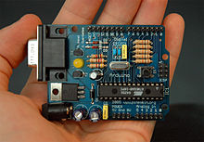
Fig.4.3: Arduino board.
Fig.4.4. Pin explanation.
Table 4.1 Pin Diagram Description
1 | POWER USB:  Arduino board can be powered by using the USB cable from your computer. All you need to do is connect the USB cable to the USB connection (1).
2 | POWER(BARREL JACK):  Arduino boards can be powered directly from the AC mains power supply by connecting it to the Barrel Jack (2).
3 | VOLTAGE REGULATOR:  The function of the voltage regulator is to control the voltage given to the Arduino board and stabilize the DC voltages used by the processor and other elements.
4 | CRYSTAL OSCILLATOR  The crystal oscillator helps Arduino in dealing with time issues. How does Arduino calculate time? The answer is, by using the crystal oscillator. The number printed on top of the Arduino crystal is 16.000H9H. It tells us that the frequency is 16,000,000 Hertz or 16 MHz.
5,17 | ARDUINO RESET  You can reset your Arduino board, i.e., start your program from the beginning. You can reset the UNO board in two ways. First, by using the reset button (17) on the board. Second, you can connect an external reset button to the Arduino pin labelled RESET (5).
6,7,8,9 | PINS (3.3, 5, GND, Vin):  - 3.3V (6) − Supply 3.3 output volt  - 5V (7) − Supply 5 output volt  - Most of the components used with Arduino board works fine with 3.3 volt and 5 volt.  - GND (8)(Ground) − There are several GND pins on the Arduino, any of which can be used to ground your circuit.  Vin (9) − This pin also can be used to power the Arduino board from an external power source, like AC mains power supply.
10 | ANALOG PINS:  The Arduino UNO board has six analog input pins A0 through A5. These pins can read the signal from an analog sensor like the humidity sensor or temperature sensor and convert it into a digital value that can be read by the microprocessor.
11 | MAIN MICROCONTROLLER:  Each Arduino board has its own microcontroller (11). You can assume it as the brain of your board. The main IC (integrated circuit) on the Arduino is slightly different from board to board. The microcontrollers are usually of the ATMEL Company. You must know what IC your board has before loading up a new program from the Arduino IDE. This information is available on the top of the IC. For more details about the IC construction and functions, you can refer to the data sheet.
12 | ICSP PIN:  Mostly, ICSP (12) is an AVR, a tiny programming header for the Arduino consisting of MOSI, MISO, SCK, RESET, VCC, and GND. It is often referred to as an SPI (Serial Peripheral Interface), which could be considered as an "expansion" of the output. Actually, you are slaving the output device to the master of the SPI bus.
13 | POWER LED INDICATOR  This LED should light up when you plug your Arduino into a power source to indicate that your board is powered up correctly. If this light does not turn on, then there is something wrong with the connection.
14 | TX AND RX LEDS:  On your board, you will find two labels: TX (transmit) and RX (receive). They appear in two places on the Arduino UNO board. First, at the digital pins 0 and 1, to indicate the pins responsible for serial communication. Second, the TX and RX led (13). The TX led flashes with different speed while sending the serial data. The speed of flashing depends on the baud rate used by the board. RX flashes during the receiving process.
15 | DIGITAL INPUT-OUTPUT:  The Arduino UNO board has 14 digital I/O pins (15) (of which 6 provide PWM (Pulse Width Modulation) output. These pins can be configured to work as input digital pins to read logic values (0 or 1) or as digital output pins to drive different modules like LEDs, relays, etc. The pins labeled “~” can be used to generate PWM.
16 | AREF:  AREF stands for Analog Reference. It is sometimes, used to set an external reference voltage (between 0 and 5 Volts) as the upper limit for the analog input pins.

4.3 Conclusion:
Each pin of arduino controller is explained in detail.

Chapter-5
Software Explanation
5.1 Introduction:
This project is implemented using following software’s:
    - Express PCB – for designing circuit
    - Arduino IDE compiler - for compilation part
    - Proteus 7 (Embedded C) – for simulation part

5.2 Interface:
When a project is first started you will be greeted with a yellow outline. This yellow outline is the dimension of the PCB. Typically after positioning of parts and traces, move them to their final position and then crop the PCB to the correct size. However, in designing a board with a certain size constraint, crop the PCB to the correct size before starting.

Fig: 5.1 show the toolbar in which the each button has the following functions:

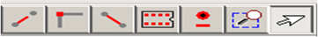

Fig: 5.1 Tool bar necessary for the interface
5.2.1 The Select Tool:
It is fairly obvious what this does. It allows you to move and manipulate parts. When this tool is selected the top toolbar will show buttons to move traces to the top / bottom copper layer, and rotate buttons.
The zoom to selection tool: does just that.
5.2.2 The Place Pad:
Button allows you to place small soldier pads which are useful for board connections or if a part is not in the part library but the part dimensions are available. When this tool is selected the top toolbar will give you a large selection of round holes, square holes and surface mount pads.
5.2.3 The Place Component:
Tool allows you to select a component from the top toolbar and then by clicking in the workspace places that component in the orientation chosen using the buttons next to the component list. The components can always be rotated afterwards with the select tool if the orientation is wrong.
5.2.4 The Place Trace:
Tool allows you to place a solid trace on the board of varying thicknesses. The top toolbar allows you to select the top or bottom layer to place the trace on.
5.2.5 The Insert Corner in Trace:
Button does exactly what it says. When this tool is selected, clicking on a trace will insert a corner which can be moved to route around components and other traces.
The remove a trace button is not very important since the delete key will achieve the same result.
5.3 Design Considerations:
Before starting a project there are several ways to design a PCB and one must be chosen to suit the project’s needs. Single sided, or double sided.,
When making a PCB you have the option of making a single sided board, or a double sided board. Single sided boards are cheaper to produce and easier to etch, but much harder to design for large projects. If a lot of parts are being used in a small space it may be difficult to make a single sided board without jumpering over traces with a cable. While there’s technically nothing wrong with this, it should be avoided if the signal travelling over the traces is sensitive (e.g. audio signals).

A double sided board is more expensive to produce professionally, more difficult to etch on a DIY board, but makes the layout of components a lot smaller and easier. It should be noted that if a trace is running on the top layer, check with the components to make sure you can get to its pins with a soldering iron. Large capacitors, relays, and similar parts which don’t have axial leads can NOT have traces on top unless boards are plated professionally.
5.4 Arduino Compiling:
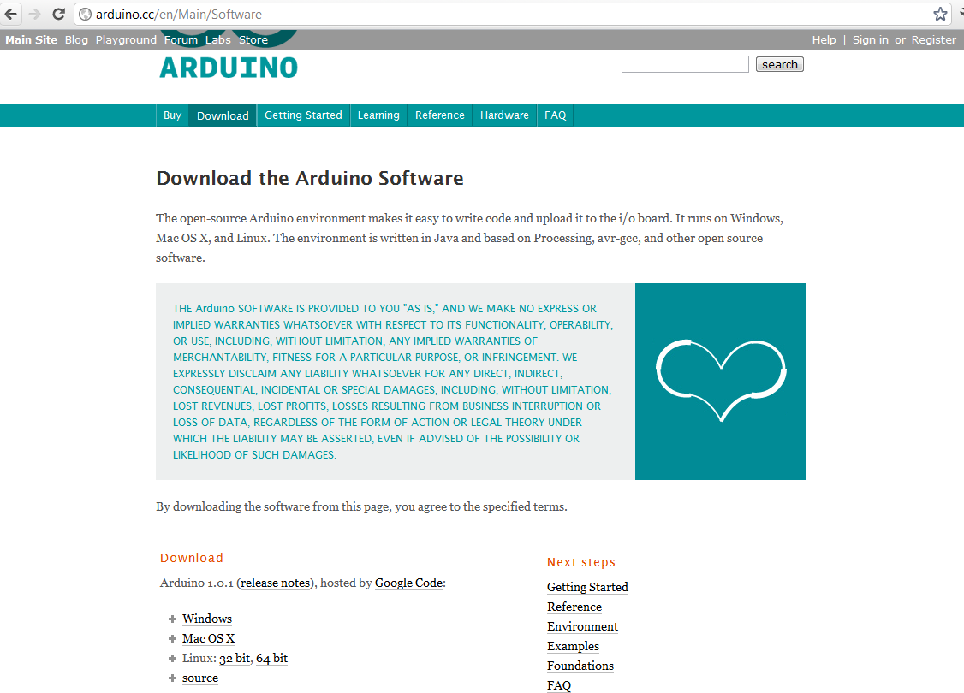

In next step download library
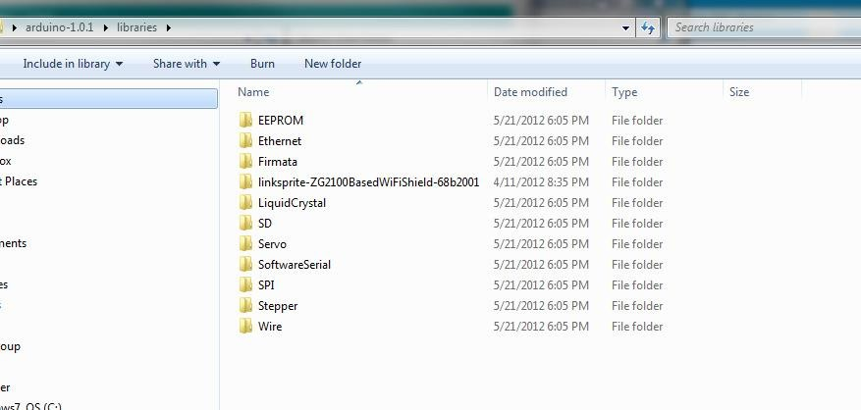
As Arduino doesn’t recognize the directory name, please rename it
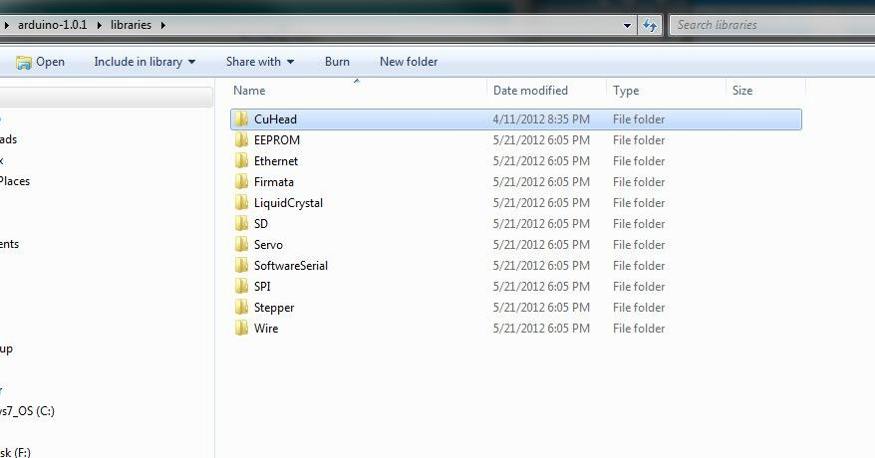

Launch Arduino by double click “Arduino” below
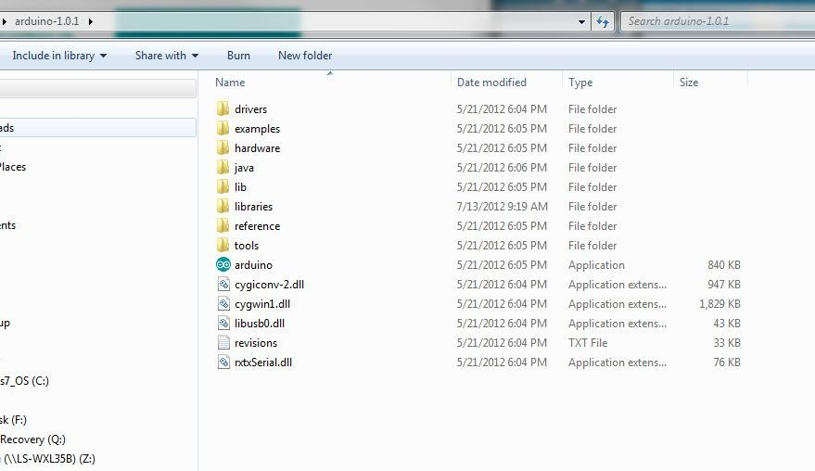

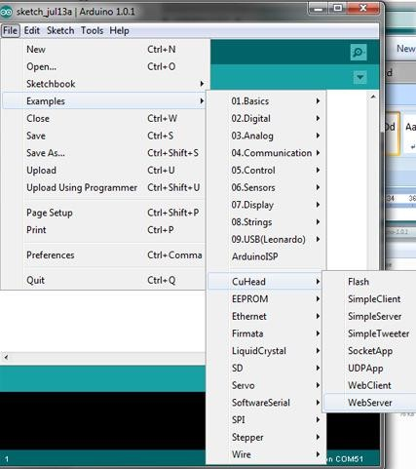
One example:
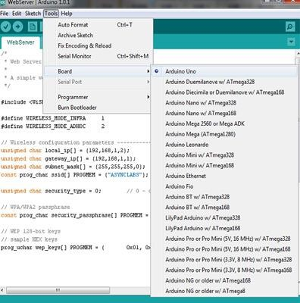
Select the target board as “Arduino Uno”:

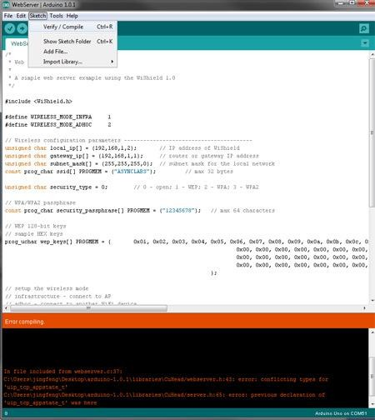
Click Sketch-> Verify/Comp

CHAPTER-6
ADVANTAGES AND LIMITATIONS
ADVANTAGES:
- Traffic operates based on traffic congestion automatically.
- Safety from road accidents
- Due to the deployment of this system, the chances of road accidents can be minimized.
- Reduction in pollution: Due to the good management of traffic flow, pollution can be reduced.

LIMITATIONS:
- An IoT based real-time traffic monitoring system is proposed [43] for dynamic handling of traffic signals based on traffic density. ..
- . The ultrasonic sensors are used to detect vehicles, and the density levels of a given road are sent to an LCD, and the data sent to the server for later usage.

CHAPTER-7
CONCLUSION
CONCLUSION In this paper, we have proposed an emergency contact and location tracking system for vehicular emergencies on road. The system is fully automatic in nature that can help us to minimize accidental and other emergency damages. This prototype is mainly designed for smart cities and IoT enabled vehicles. However, this system may also be used with existing infrastructure in any cities. This proposed system is only able to send emergency information from a vehicle to nearby rescue centers, but it can’t help to avoid any emergency issues. Also, the system is dependent on several mechanical and electrical devices in a car to detect accident or other emergencies. In future, we would like to include these concerns. Also, we are aiming to design a hardware secured [22] on chip (System-on-Chip / Network-on-Chip) system featuring these services in future

CHAPTER-8
BIBLIOGRAPHY
REFERENCE :
[1] L. Atzori, A. Iera, and G. Morabito, “The Internet of Things: A Survey,” Computer Networks, vol. 54, no. 15, pp. 2787–2805, 2010. [2] E. A. Lee, “Cyber Physical Systems: Design Challenges,” in Object Oriented Real-Time Distributed Computing (ISORC), 2008 11th IEEE International Symposium on. IEEE, 2008, pp. 363–369. [3] A. Zanella, N. Bui, A. Castellani, L. Vangelista, and M. Zorzi, “Internet of Ihings for Smart Cities,” Internet of Things Journal, IEEE, vol. 1, no. 1, pp. 22–32, 2014. [4] “Digital India,” Online, 2015, (Last accessed March 18, 2016). [Online]. Available: http://www.digitalindia.gov.in/ [5] J. Gubbi, R. Buyya, S. Marusic, and M. Palaniswami, “Internet of Things (IoT): A Vision, Architectural Elements, and Future Directions,” Future Generation Computer Systems, vol. 29, no. 7, pp. 1645–1660, 2013. [6] M. Chen, “Towards Smart City: M2M Communications with Software Agent Intelligence,” Multimedia Tools and Applications, vol. 67, no. 1, pp. 167–178, 2013. [7] NCRB, “Accidental Deaths and Suicides in India 2014,” New Delhi: National Crime Records Bureau, Ministry of Home Affairs, Tech. Rep., 2015. [8] G. Van Brummelen, Heavenly Mathematics: The Forgotten Art of Spherical Trigonometry. Princeton University Press, 2013. [9] A. Cenedese, A. Zanella, L. Vangelista, and M. Zorzi, “Padova Smart City: An Urban Internet of Things Experimentation,” in World of Wireless, Mobile and Multimedia Networks (WoWMoM), 2014 IEEE 15th International Symposium on a. IEEE, 2014, pp. 1–6. [10] J. Maleki, E. Foroutan, and M. Rajabi, “Intelligent Alarm System for Road Collision,” Journal of Earth Science and Engineering, vol. 1, no. 3, 2011. [11] F. J. Martinez, C.-K. Toh, J.-C. Cano, C. T. Calafate, and P. Manzoni, “Emergency Services in Future Intelligent Transportation Systems Based on Vehicular Communication Networks,” Intelligent Transportation Systems Magazine, IEEE, vol. 2, no. 2, pp. 6–20, 2010. [12] C. Thompson, J. White, B. Dougherty, A. Albrig

